**Ideation Phase**

**IDEATION**

**Brainstorm & Idea Prioritization Template:**

[Brainstorming provides a free and open environment that encourages everyone within a team to participate in the creative thinking process that leads to problem solving. Prioritizing volume over value, out-of-the-box ideas are welcome and built upon, and all participants are encouraged to collaborate, helping each other develop a rich amount of creative solutions.](https://www.mural.co/templates/empathy-map-canvas)

**Step-1: Team Gathering, Collaboration and Select the Problem Statement**

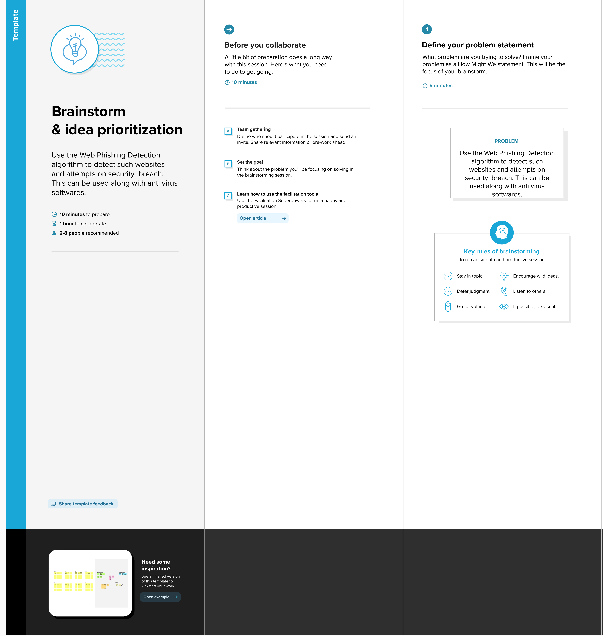

**Step-2: Brainstorm, Idea Listing and Grouping**

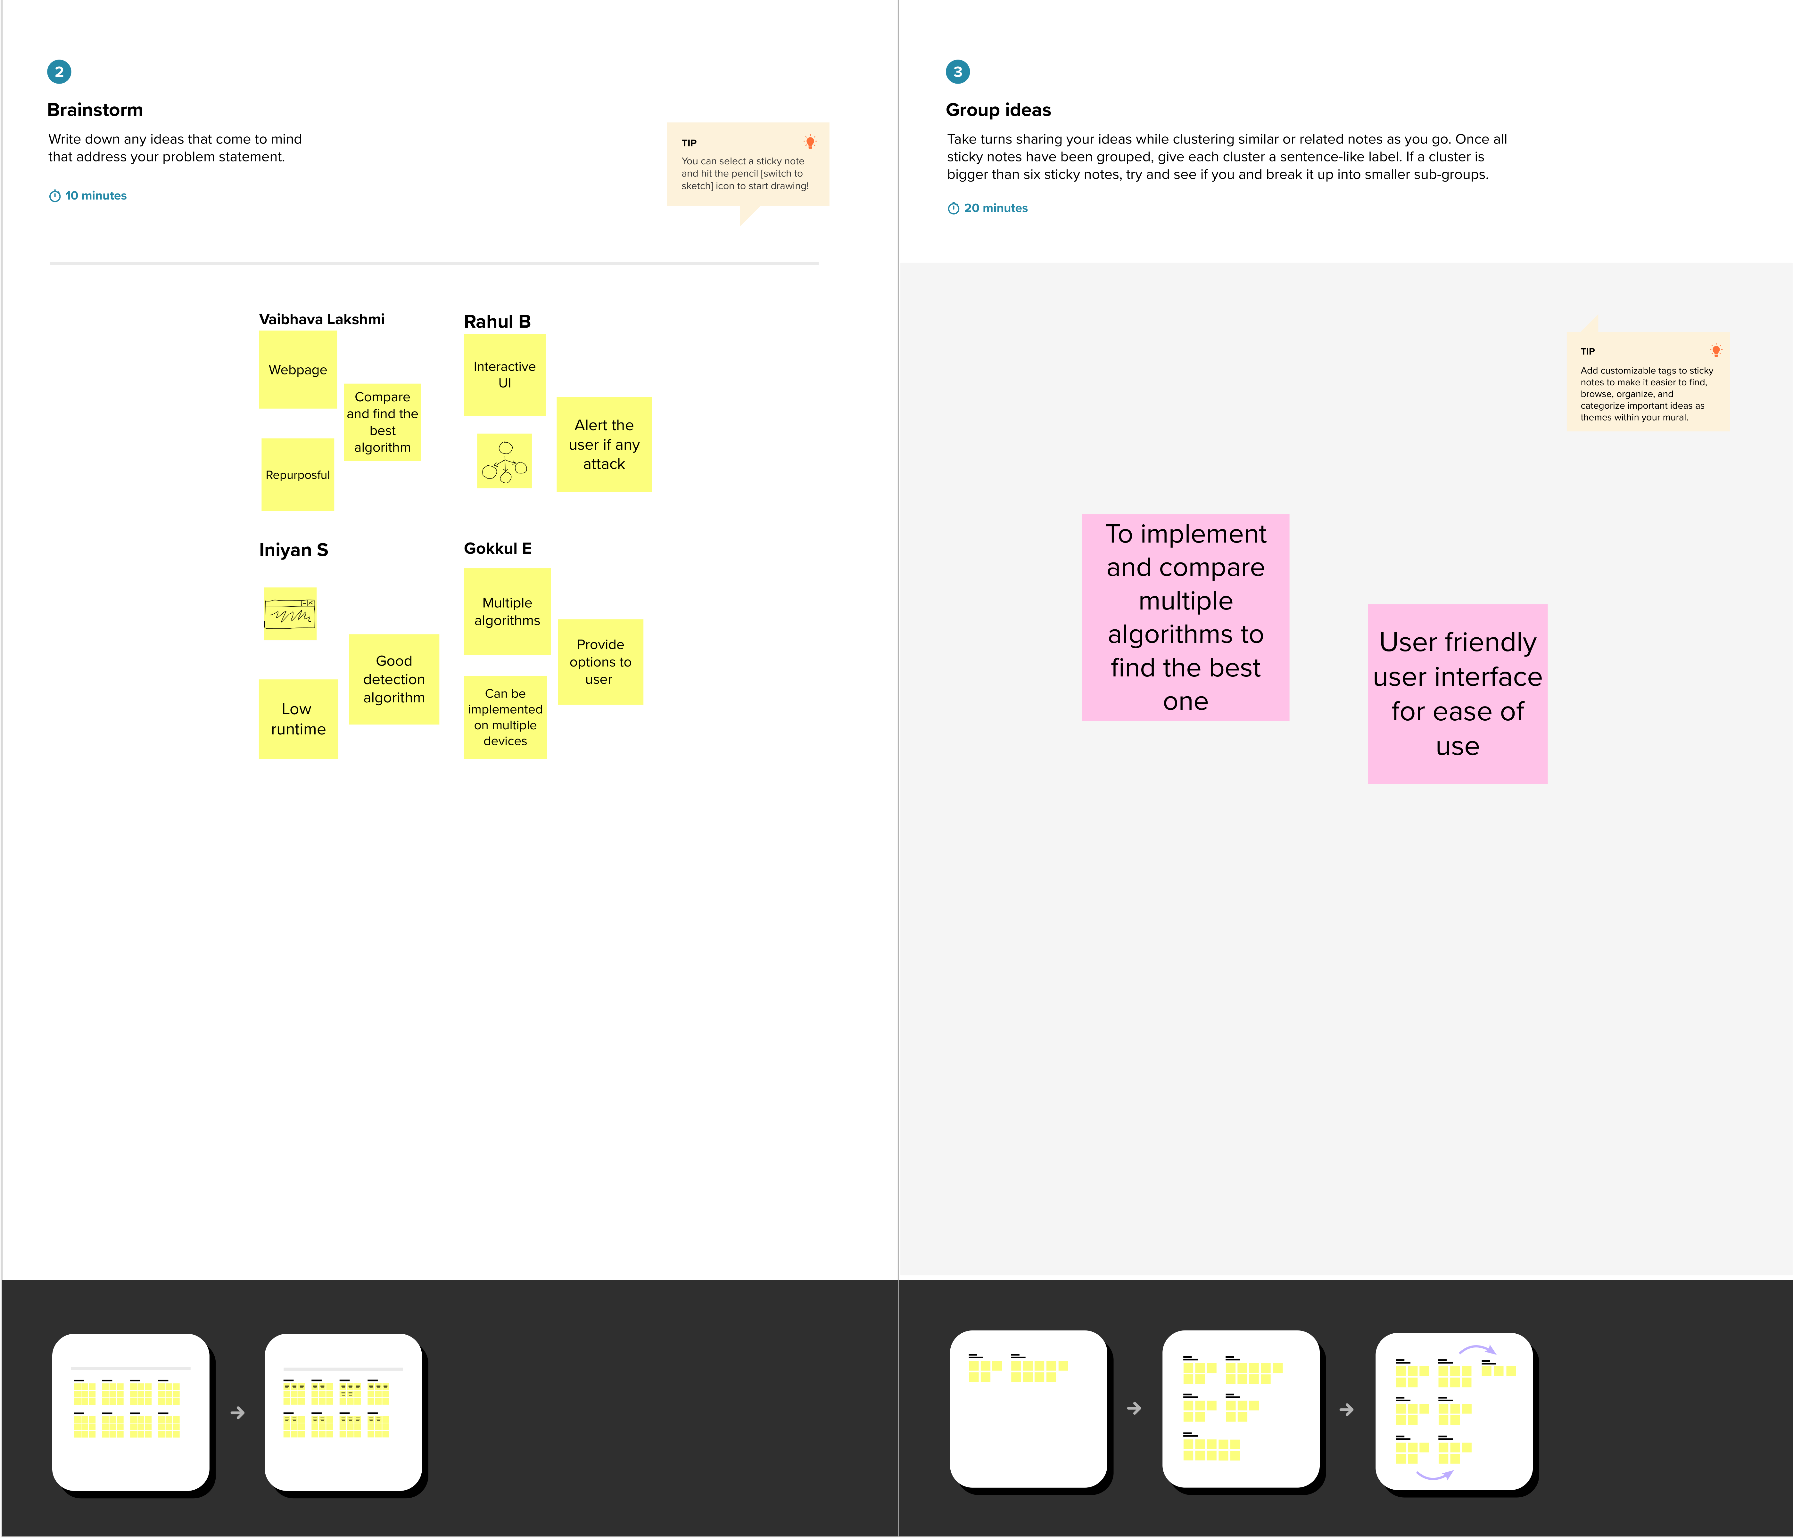

**Step-3: Idea Prioritization**

